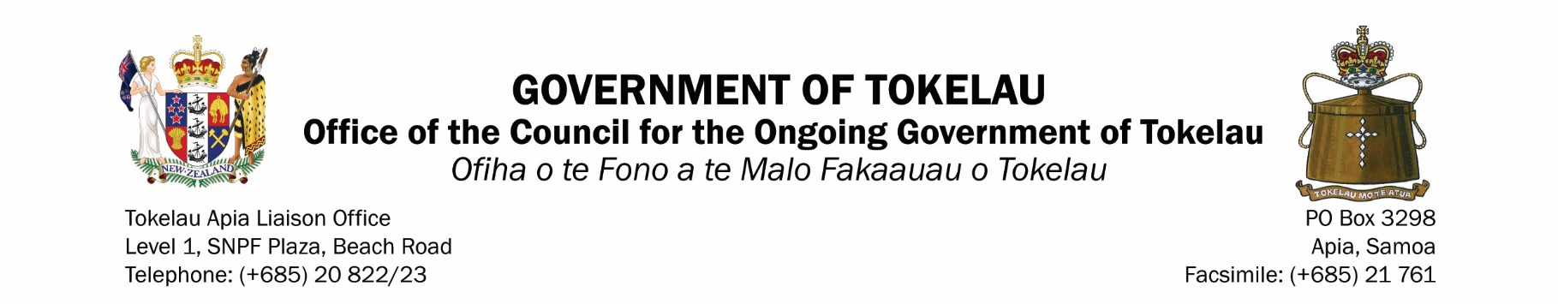

TOKELAU BORDER & RESTRICTIONS
AS AT 30 NOVEMBER 2022

WHO CAN TRAVEL TO TOKELAU DURING BORDER CLOSURE

- TPRS and their accompanying family members who have been cleared by the Department of Health to return to Tokelau;
- Returning residents who travelled out of Tokelau before border closures but stranded overseas because of Covid-19 restrictions and could not make the initial repatriation in 2020;
- Nationals usually resident overseas but are relocating to Tokelau for 6 months or more
- Essential workers including front liners with prior approval under exemption from the National Executive Board for COVID19;
- Students (under the Scholarship Scheme or Private sponsorship) on home leave;
  - Residents who travelled out of Tokelau during border closure for emergency situation as determined by the villages

ENTRY REQUIREMENT INTO TOKELAU

The entry requirement into Tokelau as effective from 30 November 2022:

Checks in Apia
- Passengers must be fully vaccinated with Pfizer or other WHO approved vaccine for Covid-19.

- Fully vaccinated is: 2 doses + booster for 12 years of age and above, and 2 doses for travellers 5 – 11 years of age. Those vaccinated outside of Tokelau must show hard copies of vaccine certificate;

- Passengers must show a negative PCR result within 48 hours of vessel departure for Tokelau from Apia;

- Clear medical report by a certified Medical Officer to verify there is no Covid-19 symptoms and historical covid-19 status, plus a clean general health conditions;

- Passengers must show a negative RAT result within 24 hours of vessel departure for Tokelau from Apia;

- Passengers must clear TALO Health Screening not less than 1 hour before getting on the vessel to travel to Tokelau

Extra Requirement in Apia

- Passengers who picked up positive results for Covid-19 during the 48 hours PCR tests will be required to return 2 consecutive negative RAT results 7 days apart (14 days total) before they are considered for entry into Tokelau.

- Passengers who have returned 2 consecutive negative RAT results will then need to only return a negative RAT result as in Checks in Apia – 24 hours before they travel to Tokelau.

- However, if a passenger has not secured a berth on the vessel to return to Tokelau for over 28 days from the day they were positive with Covid-19 they are required to complete another PCR test as required under Checks in Apia

Requirements on Arrival in Tokelau

- All passengers follow villages Covid-19 protocol for travel from ship to shore and onward to quarantine favilities;
- All passengers and crew of barges are to quarantine for 7 days (24 hour count)

All passengers and crew must return a negative RAT result on Day 1 & 6 and meet all other health requirements before being released to the communities

